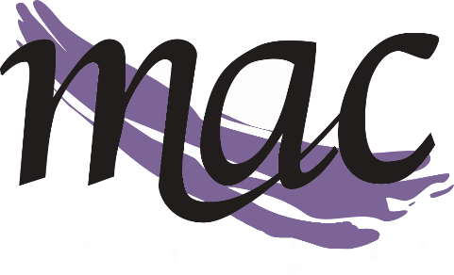
Middletown Arts Center 130 N. Verity Parkway - Middletown, Ohio 45042 - 513-424-2417

STUDIO GALLERY CONSIGNMENT AGREEMENT

Artist Name: ______________________________________________________________________________________________________________

Street address: ____________________________________________________________________________________________________________

City, State, Zip: ____________________________________________________________________________________________________________

Phone Day/Phone Evening: _______________________________________________________________________________________________

E-mail/Website: ___________________________________________________________________________________________________________

Beginning Date of Consignment: _______________________________

The MIDDLETOWN ARTS CENTER is located at 130 N. Verity Parkway, Middletown, Ohio 45042. The building is located on the City Centre Plaza in the downtown area. The lobby houses a small gift area and receives traffic from persons attending classes, exhibits, rehearsals, performances and organizational meetings. Building hours vary.

TERMS AND CONDITIONS:

MATERIALS REQUIRED – PLEASE SUBMIT ELECTRONICALLY IF POSSIBLE
Inventory List - A typed or printed inventory list should be submitted with the artwork including the name of the artist, identifying number, title, media and price for each piece. From this list MAC will prepare title cards or price tags.
Artist Biography – Artist should submit a brief bio along with a picture, portrait or representative art, to be included on our website and displayed in the Studio Gallery
LIABILITY
All reasonable care will be taken in handling work submitted; however, The Middletown Arts Center, the Exhibit Committee, nor the Installation Committee will be responsible for loss or damage to works of art. All works are entered at the artist's own risk, and the artist must provide his/her own insurance.

SALE OF ARTWORK
All accepted artwork will be for sale at the Middletown Arts Center. Some, or possibly all, artwork could be available for sale on the MAC website. The MAC gallery will retain a commission of 30% on all works sold. As a non-profit organization, MAC is exempt from charging sales tax on commissioned items. Artist is responsible for reporting sales tax on work sold based on the sale price. Commissions will be paid monthly, the month following the sale of artwork.

PUBLICITY
The Middletown Arts Center reserves the right to have work photographed or videotaped for reasonable publicity purposes.

REMOVAL/RETURN OF ARTWORK
All artwork is taken in on an ongoing basis unless specifically stated otherwise. If MAC determines the artwork should be returned notice will be given to artist. MAC will make three attempts at contacting the artist. If artist does not contact MAC within 60 days of 3rd contact attempt, MAC shall regard the artwork as abandoned property and become the property of MAC. It may be sold or disposed of in a manner decided by MAC.

If the Artist would like to remove any artwork, whether temporarily or permanently, notice should be given to the MAC at least 1 week in advance. Artwork must be officially checked out of inventory with MAC staff.

ARTIST’S WARRANTIES/COPYRIGHT
The artist certifies that all works on exhibit and/or on display for purchase are original, have been created by the artist or a represented artist and are not a mechanical or other reproduction. The artist further certifies that artist owns the copyright to each work and grants the MAC the right to transfer this right to the purchaser (if applicable).

I the undersigned understand and agree to the above stated conditions of this exhibition/loan agreement.

Artist/Agent Signature: ____________________________________________________________________________________________________

Date: _______________________________________________________________________________________________________________________

